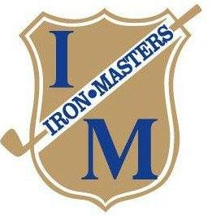
Iron Masters 2 Man Fall Shoot-Out
October 4, 2026
10:00 AM Shotgun

Format: Holes 1-6 Better Ball, Holes 7-12 Modified Alternate Shot, Holes 13-18 Scramble
Prizes: Teams will be divided into 3 divisions based on handicap and at the discretion of the Golf Committee
Cash Prizes will be awarded for each format and the Overall. Prize amounts will be determined by number of teams in each division.
Entry Fee: $190 Per Team includes tournament, cart, and meal.
Field Limited to First 50 Paid teams
Entries must be received by September 29, 2026

Player 1: Player 2:
Name: ____________________________ Name: ______________________________
Address: __________________________ Address: ____________________________
___________________________ ____________________________
Phone: ____________________________ Phone: _____________________________
E-Mail: ____________________________ E-Mail: _____________________________
Handicap: __________________________ Handicap: ___________________________
Course Affiliation: ___________________ Course Affiliation: ____________________

Entries can be mailed to: Iron Masters Country Club, 174 Cross Cove Rd., Roaring Spring, PA 16673 or by calling the Pro Shop: (814) 224-2915

